HTTP
This is out of the box API in Angular that allows us to make HTTP requests (GET, POST, PUT, DELETE, PATCH, etc.) to communicate with the backend server. This HttpClient API is available in package @anhular/common/http. This API always returns an observable object, hence it needs to be subscribed.
- Angular HTTP Client
It provides:
- GET, POST PUT, DELETE, PATCH requests
- Request & response handling
- Strong typing with TypeScript
- Error handling
- HTTP Headers
- Query Parameters
- Interceptors
- Observables using RxJS
e.g.
Enable HTTP communication by importing HttpClientModule (not required if you are using Angular 17 or higher).
// app.module.ts
import { NgModule } from '@angular/core';
import { BrowserModule } from '@angular/platform-browser';
import { HttpClientModule } from '@angular/common/http';

@NgModule({ imports: [BrowserModule, HttpClientModule]
})
export class AppModule { }

import { HttpClient } from '@angular/common/http';
constructor(private http: HttpClient) { }

Why HttpClient?
Key Features of HTTPClient:
  - Simplified API for sending the HTTP requests
  - Automatic JSON conversion
  - Support RxJS Observable
  - Interceptors for request & response modification
  - Strong TypeScript typing
  - Better testing support
- HTTP GET Example
- HTTP POST Example
- Passing URL Parameters (Query strings)
- HTTP Headers Example
- HTTP Interceptor
The Angular interceptor helps us to modify the HTTP request by intercepting it before the Request is sent to the back end. It can also modify the incoming Response from the back end. It globally catches every outgoing & in coming request at a single place. We can use it to add custom headers to the outgoing requests, log the incoming responses, etc.

Interceptor flow:
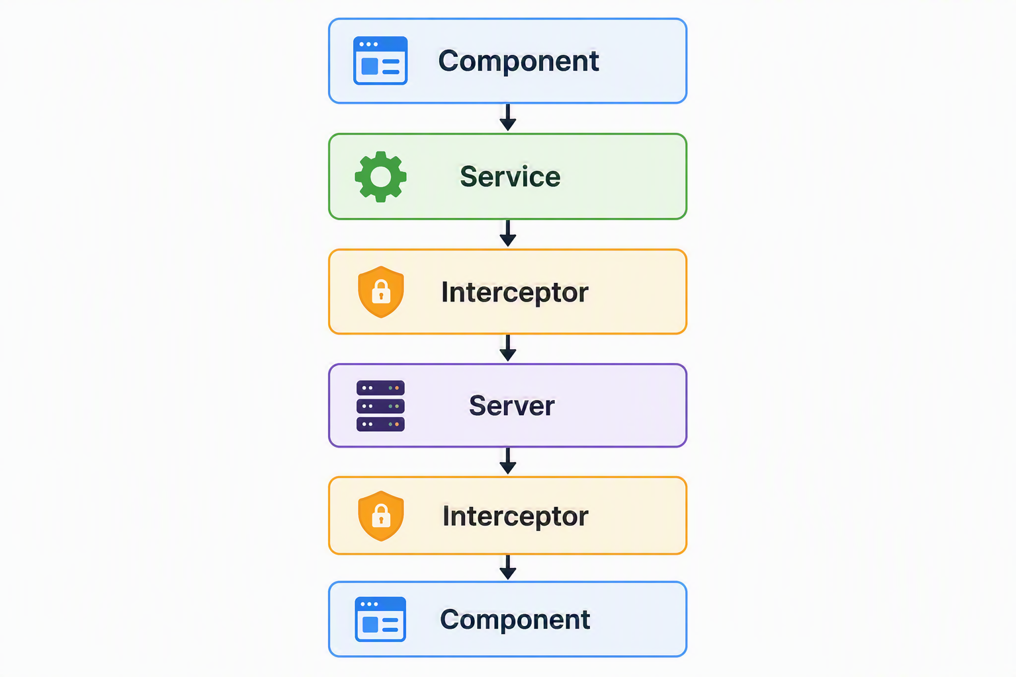

Angular Router
- Angular Router with standalone components
- Location Strategies in Angular Router
- Passing Parameters to Route
- Child Routes / Nested Routes
- Query Parameters
- Navigation between Routes
- Angular Pass data to route
- RouterLinkActive
- Router Events
- ActivatedRoute
Angular Route Guards
- CanActivate Guard
- CanActivateChild Guard
- CanDeactivate Guard
- Angular Resolve Guard
Using Bootstrap in Angular

